**MINISTRY OF EDUCATION, CULTURE AND RESEARCH OF REPUBLIC OF MOLDOVA TECHNICAL UNIVERSITY OF MOLDOVA**

**FACULTY OF COMPUTERS, INFORMATICS AND MICROELECTRONICS DEPARTMENT OF SOFTWARE ENGINEERING AND AUTOMATICS**



MULTIMEDIA TECHNOLOGY COURSE

Laboratory work 3

Elaborated:

st.gr. FAF-212 Botezatu Marius

Buzu Alexandru

Frunze Vladislav

Lupascu Felicia

Ursu Vlad

Verified:

asist.univ. Petici Marina

Chișinău 2023

**Task:** Implement a SANDBOX type of game using Unity.

**Title**: "Long Live Cobrastan"

**Storyline**:

In the 2D game "Long Live Cobrastan," you embark on a thrilling adventure driven by the eccentric plans of your beloved yet slightly unhinged grandfather. Determined to establish his own independent nation, he devises a cunning strategy to obtain resources and strongarm the United States into recognizing his backyard as a sovereign territory. As the main player, you embark on a series of missions involving mining, crafting, and nuclear engineering.

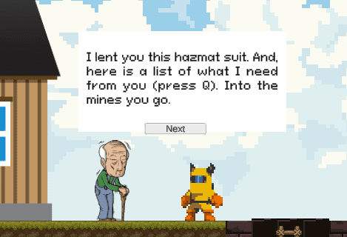

**Game Physics:**

In our game there are all physical laws that the Unity engine possesses, but we put more emphasis and had to modify:

**Gravity** - when the player jumps and falls

**Frictional force** - when the player slides



**Object Interaction Mechanics:**

Object Interaction: Players can destroy ores, interact with the dropped resources, and also telekinetically move crates.

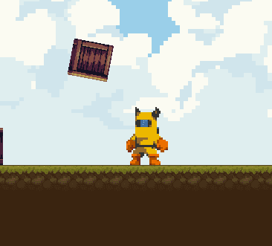

**How the AI works:**

In our game we chose to have some enemies, some birds flying around. An AI enemy gives players a dynamic and challenging opponent to overcome. The unpredictable behavior and decision-making of enemy AI keeps players engaged, pushing them to develop strategies, improve their skills, and find creative ways to outsmart or defeat their opponents. The presence of a formidable enemy AI adds depth and excitement to the game, making it more engaging and rewarding.



**Crafting Mechanism:**

Crafting recipes for several components of a nuclear bomb. Resources the player mines in the caves.

Resources: Iron Ore, Titanium Ore, Gold Ore, Beryllium Ore, Plutonium Ore.

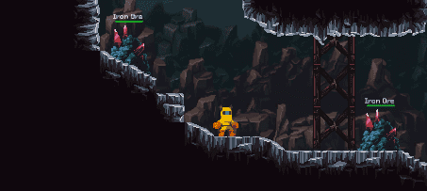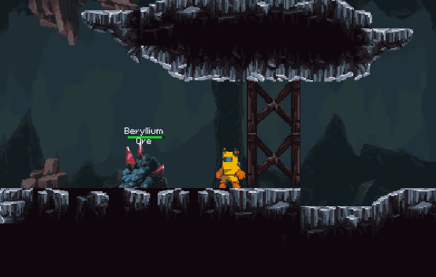

An inventory system enables players to keep track of the resources they collect, ensuring they have a clear understanding of what they possess. This helps in decision-making, as players can strategize and plan their actions based on the available resources.

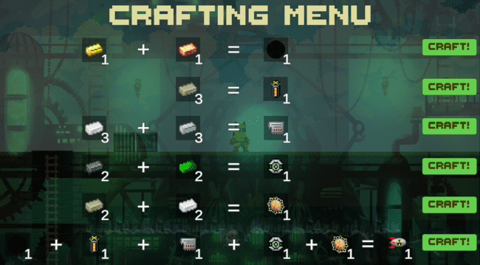

**Resources that allow to create a new one when combined:**

1 gold + 1 beryllium = initiator neutron

3 lithium = lithium deuteride

3 iron + 3 titanium = hard metal casing

2 plutonium + 2 uranium = radioactive core

2 lithium + 2 iron = explosive lenses

neutron initiator + lithium deuteride + hard metal casing + radioactive core + explosive lenses = "Special Device"